SIMULTANEOUS ESTIMATION OF TORSEMIDE AND SPIRONOLACTONE AND FORCED DEGRADATION STUDIES IN BULK AND COMBINED DOSAGE FORM BY RP-HPLC
S.Rajalakshmi *, L.Kiran kumar , V.Krishna priyanka , N.Manohar
Prabath Institute of Pharmacy, Parnapally, Kurnool Dist, AP-518501
ABSTRACT
ABSTRACT
Torsemide is a loop diuretic and Spironolactone is a high ceiling diuretic, which belong to diuretics class of drugs. A simple,RP-HPLC method was developed for the simultaneous estimation of Torsemide and Spironolactone in bulk and tablet dosage form according to ICH guidelines. The mobile phase was 80% ACN with 0.1%OPA buffer at a flow rate of 1ml/min, wave length was 235 nm and elution was isocratic mode. Injection volume was 20 L RT was 3.1 &3.9, linearity concentrations were found to be 50-250 g/ml and 125-625 g/ml respectively. Correlation coefficient was r²=0.999. Recoveries were 99.7% & 99.4%. LOD/LOQ was also done for both the drugs which were subjected to acid, alkali treatments, photo degradation etc., the method validation was performed with respect to robustness, specificity, linearity, precision and accuracy as per ICH guidelines Q2(R1)

KEYWORDS: Torsemide, Spironolactone, RP-HPLC , Degradation studies, Validation process

Introduction

Torsemide is aniline-pyridine sulphonyl urea whose IUPAC name is - ({4-[(3 methylphenyl) amino] pyridin-3-yl}sulfonyl)-3-(propan-2-yl)urea, molecular formula- C₁₆H₂₀N₄O₃S. [1]It is used as as high ceiling diuretic and cardiovascular agent by inhibiting Na⁺/K⁺ ions. Diuretics increases the rate of urine flow [2]. Spironolactone acts as an antagonist to aldosterone It acts at distal convoluted tubules. Spironolactone is dimethyl derivative of acetyl sulphone. The structure is given in (fig 1). IUPAC name is 1'S,2R,2'R,9'R,10'R,11'S,15'S)-9'-(acetylsulfanyl)-2',15'-dimethylspiro[oxolane-2,14'-tetracyclo[8.7.0.0²,⁷.0¹¹,¹⁵]heptadecan]-6'-ene-5,5'-

dione, molecular formula is C₂₄H₃₂O₄S [3-6]. It is used as potassium sparing diuretic. The structure is given in (fig 2). It acts at Henle’s loop part of nephron [7-9]. The combination of the both drugs is not official in any pharmacopoeia[10] . Deep literature survey reveals that no single method is available with the parameters used in this work. RP-HPLC methods are now-a-days increasing for the simultaneous estimation of drugs. The present study deals with a simultaneous estimation method for both the drugs in bulk and tablet form.. All the validation parameters were evaluated according to the ICH guidelines [11,12]. Degradation studies were also carried over like the previous methods to check the stability [2].

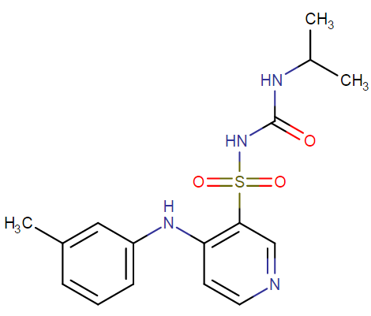
Fig 1- Structure of Torsemide
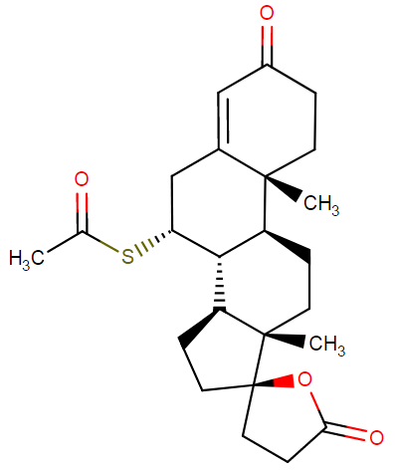
Fig 2-Structure of Spironolactone
2 .Experimental Explanation:
2.1 Chemicals and Instruments:
Torsemide and Spironolactone API was supplied by Pharmatrain Labs, Ortho phosphoric acid by FINAR chemicals LTD, HCl-H₂O₂-NaOH by MERCK Labs. HPLC grade water, Methanol and Acetonitrile by Standard solutions Ltd. HPLC instrument used was WATERS-2695 separation module with UV detector. Empower software was used.

2.2 Chromatographic conditions:
Separation was achieved on Inertsil ODS column of (4.6 250mm, 5 m) with a mobile phase of 20%0.1%OPA buffer and 80% ACN. The wave length was selected as 235 nm with 10 minutes run time. The flow rate was adjusted as 20µL.
2.3 Wave length Optimization:
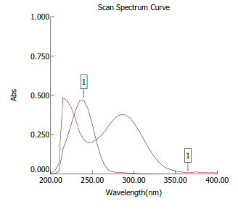
Fig: 3- Isobestic point
The UV spectrum of TOR and SPR were recorded by scanning in the range of 200-400nm. At 235 nm both the drugs showed good absorbance.
2.4 Standard solutions:
10 mg of TOR and 25 mg of SPR working standard solutions were prepared and transferred into a 10 ml clean dry volumetric flask and 7 ml of diluent was added and sonicated to dissolve it completely and the volume was made up to the mark with the same solvent. (Stock solution) Further pipetted 1.5 ml of the above stock solutions into a 10ml volumetric flask and diluted up to the mark with diluents same solvent. (Stock solution) Further pipetted 1.5 ml of the above stock solutions into a 10ml volumetric flask s
2.5 Calibration graphs:
The stock solutions were prepared for 5 different concentrations. TOR drug was prepared from 50-150 g/ml and SPR was prepared from 125-625 g/ml. These five concentrations were injected and linearity was recorded as correlation coefficient. These five concentrations were injected and linearity was recorded as correlation coefficient.
2.6 Assay of the Tablet:
20 tablets were powdered and approximately 10 mg equivalent weight of TOR and 25 mg of SPR samples were weighed into a 10 ml clean dry volumetric flask add about 7 ml of diluent was added and sonicated to dissolve. Further pipetted 1.5 ml of the above stock solutions into a 10ml volumetric flask and diluted up to the mark with diluent. The final concentration of TOR is 150 µg/ml and SPR is 375 µg/ml. The chromatogram of standard and sample was shown in (fig 4) & (fig 5)
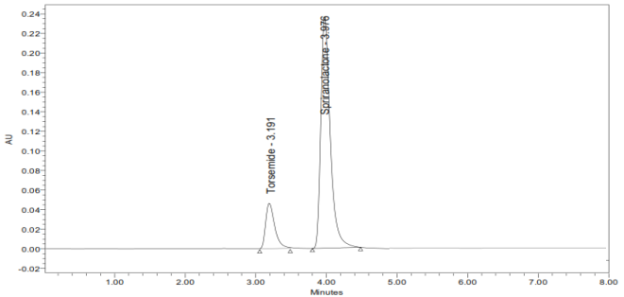
Fig:4- Chromatogram of Torsemide and Spironolactone (sample)

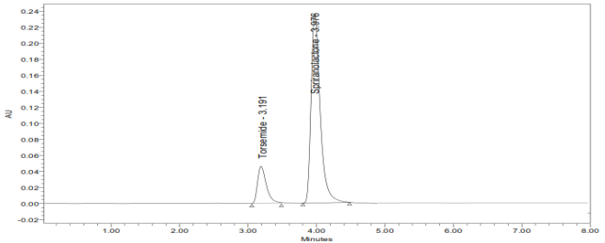
Fig:5- Chromatogram of Torsemide and Spironolactone (sample)

.S.No | Parameters | Torsemide data | Spironolactone data
1. | Optimum concentration range(mg/ml) | 50µg/ml to 250µg/ml | 125µg/ml to 625µg/ml
2. | Regression equation | Y=693.53x+2487.2 | Y=502.71x+4659.6
3. | Correlation coefficient (r²) | 0.999 | 0.999
4. | Limit of quantification LOQ(mg/mL) | 10.00 | 9.95
5. | Limit of detection, LOD(mg/mL) | 2.95 | 3.00
6. | Accuracy | 10%,100%, 150%= 99.74 | 10%,100%, 150%= 99.40
7. | Precision | % RSD=0.1%, SD=148.4 | %RSD=0.7%, SD=1308.1
8. | Robustness | 0.9ml-1.1ml | 0.9ml-1.1ml
9. | Ruggedness | RSD=0.2(area) & 0.09 (RT) | RSD=0.4(area) & 0.09 (RT)

Table 1- Statistical data of Torsemide and Spironalactone (sample)

3. Results and Discussion:

3.1 Optimization of the chromatographic conditions:

After putting many trials by different columns like Xterra C18 (4.6 x 150mm, 5.0μm), Xterra C18 (4.6 x 150mm, 5.0μm), Xterra C18 (4.6 x 100mm, 5.0μm), Waters C18 (4.6 x 150mm, 5.0μm) and different mobile phases like 50% Water: 50% Methanol, 50% Water: 50% Acetonitrile, 60% Phosphate buffer pH6: 40% Acetonitrile, 80% Phosphate buffer pH6: 20% Acetonitrile. Also different run times like 6/7/5 minutes were tried. At last the optimized method was found to be Inertsil ODS (4.6 x 250mm, 5.0μm), mobile phase-20% 0.1% OPA buffer: 80%ACN,flow rate-1.0 ml per min wavelength-235 nm, injection vol-20 μl, run time -10 min. The separation was achieved good. The tailing factor was 1.1 &1.4 repectively for TOR & SPR. The theoretical plate count was obtained as 3000 & 4600(>2000) according to the ICH guidelines.
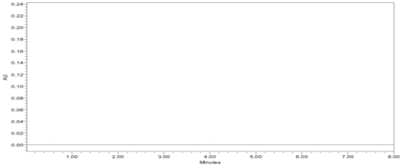

Fig 6- Chromatogram of blank solution

3.2 Specificity:
A blank solution was injected in to the HPLC system followed by the standard solution & formulation solutions of TOR & SPR were also injected, interference pattern was noted down as shown in above (fig 6)

3.3 System suitability:
The standard solution of TOR and SPR were injected into the HPLC system 6 times & % RSD of retention times, tailing factors, and theoretical plates were found to be 3.1, 1.4, and 3000 for TOR & 3.9, 1.4 & 4500 for SPR respectively.
RT(min) | Area | Height | Th plate count | Tailing factor
3.191 | 107339 | 48500 | 3009.99 | 1.14
3.195 | 107232 | 45708 | 3012.95 | 1.23
3.199 | 107131 | 42622 | 2920.27 | 1.48
3.195 | 106339 | 48500 | 3009.99 | 1.14
3.199 | 106252 | 45708 | 3012.95 | 1.48
3.201 | 106131 | 44789 | 2998.72 | 1.47

Table 2 : System suitability of Torsemide

Fig 7- Linearity of Torsemide

Fig 8- Linearity of Spironolactone
Name | RT(min) | plate count | Tailing factor | Rsn
Spr | 3.976 | 4609.37 | 1.48 | 3.43
Spr | 3.996 | 4527.44 | 1.45 | 3.41
Spr | 4.004 | 4583.24 | 1.43 | 3.43
Spr | 3.996 | 4527.44 | 1.45 | 3.41
Spr | 4.003 | 4567.78 | 1.43 | 3.41
Spr | 4.004 | 4583.24 | 1.43 | 3.43

Table 3 : System suitability of Torsemide

3.4 Linearity
5 different concentrations of TOR and SPR were selected such as 50µg/ml-250µg/ml & 125µg/ml-625 µg/ml was done. The concentrations showed good increased in areas shown as in above (figures 7 & 8)
3.5 Accuracy & Precision:
The standard solutions of TOR-SPR (50%, 100%, and 150%) were prepared & injected into the HPLC system. We were able to recover 99.74% of TOR and 99.40% OF SPR from the experiments. The standard solution of TOR-SPR was prepared and injected in to the HPLC system for 6 times and the % RSD was found to be 0.1 and 0.7 respectively.
3.6 RUGGEDNESS-LOD&LOQ-ROBUSTNESS:
The same standard solution was processed by two different analysts and on two different days. The RSD’s were found to be within the limits (<2).The lowest concentration were prepared with respect to the base line and S/N ratio was noted down. LOQ was also calculated and it was found that to be more than 3 times of LOD. Slight modification in the mobile phase (±10%) and flow rate(0.9-1.1ml) was done and chromatograms were recorded.
3.7 Assay/ Batch analysis
20 Tablets were weighed and assay was done by injecting 20µl of the standard and sample. TOR-SPR were able to be recovered as 99.47% and 100.02% respectively.
3.8 DEGRADATION STUDIES:
The standard samples were subjected to acidic, alkaline degradations, thermal and oxidative degradation and photo degradation. 1.5 ml of the standard solution was treated with 0.1 N HCl and then with 0.1 NaOH injected into HPLC system and vice versa for alkaline degradation. Then standard solution subjected to 110”C in hot air oven for thermal degradation and treated with30%w/v of H₂O₂ for oxidative degradation and also with sunlight for 24 hrs for photo degradation respectively. The chromatograms were depicted in (fig 9-13)
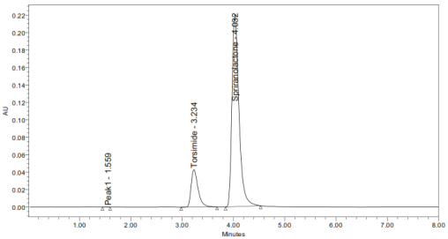
Fig 11- Chromatogram of acidic degradation
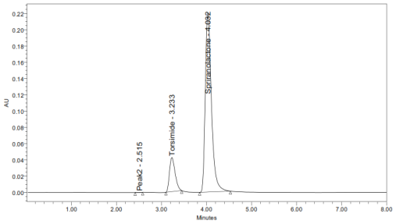 Fi g 12- Chromatogram of acidic degradation
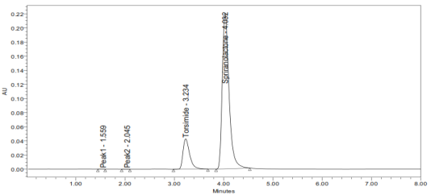
Fig 13- Chromatogram of oxidative degradation

All the degradation results showed that TOR has degraded to 7.8% and SPR has degraded to 4.3% according to the ICH guidelines.

Fig 9- Chromatogram of alkaline degradation
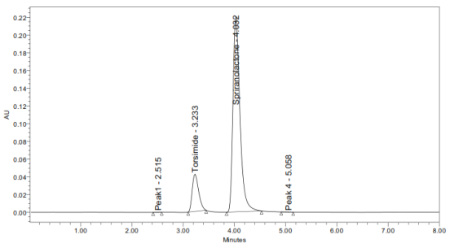
Fig 10- Chromatogram of peroxide degradation

Conclusion:
Conclusively, the RP-HPLC method described in this paper is specific, sensitive, rapid and easy to perform. The selection of this mobilphase enabled a good peak separation within less run time. The proposed method enables simultaneous determination of Torsemide and Spironolactone with good separation and resolution of the chromatographic peaks. The sample recoveries from all formulated ions were in good agreement with their respective label claims. Moreover, the present method is fast with respect to analysis time as compared to sophisticated spectrophotometric techniques. The method provided excellent specifi-city and linearity with a limit of quantification of 10.0 and 9.95, limit of detection of 2.95 and 3.00 mg/ml for TOR and SPR respectively. Finally
degradation studies were also carried on the sample solution and founded that they are only 4% and 7% were degraded. Hence the developed method can be applied in industrial application.

References

1. Smit A Bhadja, Usmangani K Chhalotiya, Dimal A Shah, Falgun A Mehta, Kashyap K Bhatt, Simultaneous Estimation Of Torsemide And Amiloride Hydrochloride In Their Pharmaceutical Dosage Form By Dual Wavelength Uv Spectroscopic Method, Adv J Pharm Life sci Res, 2014 2;1:21-28.

2.P.V.V.Satyanarayana1*, G.V.Adilakshmi, RP-HPLC Method Development Validation and Forced
Degradation Studies for Simultaneous Estimation of Torsemide and Spironolactone in Tablet Dosage Form, American Journal of Pharmtech Research,2015,5(4), 625-636

3. Jain Deepthi,R.Laxman, Acharya Ashish, Developmaent and Validation of Torsemide and Spironolactone by RP-HPLC and Spectrophotometry,International Journal of Research in Ayurveda and Pharmacy,Dec 2010,1(2),458-67.

4. Smita Sharma, M.C Sharma,D.V.Kohli, Isocratic RP-HPLC Simultaneous Estimation of Torsemide and Spironolactone,Optoelectronics and Advanced Materials-Rapid Communications, Feb2010,4(2),234-37

5. Nitin Dubey, Simulataneous Estimation of Torsemide and Spironolactone by RP-Hplc, Int Journal of Biomedical and Pharmaceutical Sciences, (2012),7(1), 38-41.
6. Amol.Y.Godge, Bhagwat N.Poul, Mohini B.Sorde, International Journal of Pharmaceutical Chemistry and Analysis, 2014,1(1), 6-13

7. Simultaneous spectrophotometric estimation of Torsemide and Spironolactone in tablet dosage form, Hiresh.K.Golker, Kavita Kapse, Sachin.K.Singh, International Journal of Pharmtech and Research,
2010, 2(4), 2246-50.

8. A simple and sensitive RP-HPLC method for simultaneous estimation of torsemide and spironolactone in combined tablet dosage form, Deshpande, P. B. Gandhi, S. V. Gaikwad, N. V. Khandagle, K. S.
http://www.akademiai.com/content/121093/ http://acta-chromatographica.us.edu.pl/

9.Spironolactone general discussion, IN-0455-0X,08/12, http://www.accessdata.fda.gov
10. Validated TLC Densitometric method for the quantification of Torsemide and Spironolactone in bulk drug and in tablet dosage form, M. C. Sharma*, Smita Sharmaa, D. V. Kohlib, A. D. Sharmac, Der Pharma Chemica 2010, 2 (1): 121-126

11.ICH guidelines, Validation of analytical procedures: Text and Methodology Q2(R1), 1996
12.ICH guidelines, Validation of analytical procedures: Text and Methodology B3(R2), 1996.

